Canal RabbitMQ Redis同步方案
CanalSync Canal同步方案
执行流程图:
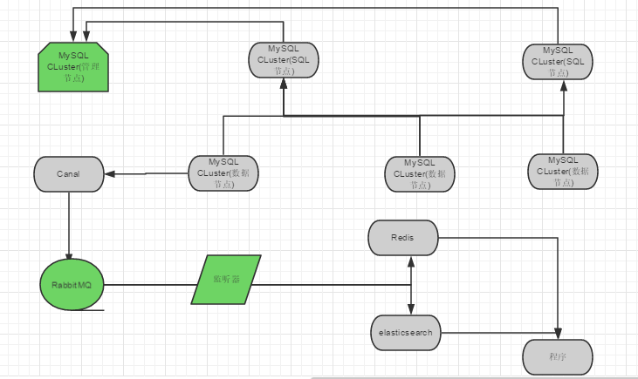

说明:
该工具主要读取Canal端及时通过Binlog数据,将数据推送至RabbitMQ队列,然后从队列取出,写入缓存或搜索引擎.

源码流程讲解:
- 获取从Canal读取的数据

在DataFactoryRunnable类中,message = connector.getWithoutAck(batchSize, timeout, TimeUnit.SECONDS); // 获取指定数量的数据
获取指定条数据
然后将读取的数据加入LinkedBlockingQueue队列,等待其他线程操作.
//通知确认,下次不再取该条数据
connector.ack(batchId);
通知Canal确认该条数据

以上操作由单独一个线程维护.

- 启动发送数据至RabbitMQ的线程,线程数为当前PC核数减一
启动线程如下:

//通知确认,下次不再取该条数据
connector.ack(batchId); // 提交确认
// 提交确认后需要读取该数据
startReadDate();
// connector.rollback(batchId); // 处理失败, 回滚数据
}
}

public void startReadDate() {
if (ctq.size() == 0)
return;
for (int i = 0; i < Runtime.getRuntime().availableProcessors() - 1; i++) {
threadPool.execute(new Task2Queue(ctq,new RabbitMQService()));
}
}

线程读取与操作代码如下:

private RabbitMQService rs;
public Task2Queue(LinkedBlockingQueue<Entry> queue,RabbitMQService rs) {
super();
this.queue = queue;
this.rs=rs;
}
@Override
public void run() {
Entry entry;
L.info("Queue's size "+queue.size());
try {
while(null!=(entry=queue.take())){
L.info("Read Queue's Resources begin...");
parseRowData2RabbitMQ(entry,rs);
L.info("Read Queue's Resources stop...");
}
} catch (InterruptedException e) {
e.printStackTrace();
}
}

该方法会将本次队列任务全部执行完成

- 转换Canal数据写入RabbitMQ
CanalFactory为Canal公共方法,protected void parseRowData2RabbitMQ(@NotNull Entry entry,RabbitMQService rs)会将Canal数据转换为JSON并写入RabbitMQ.

- RabbitMQ监听器

包org.carl.canal.listener下为RabbitMQ监听器,现暂为3个,配置文件为spring-rabbitmq.xml

例CanalInsertLitener.
监听器只需实现 org.springframework.amqp.core.MessageListener 接口,并复写public void onMessage(Message msg)方法即可,该方法将在RabbitMQ数据生成时自动执行该方法.

配置文件:
RabbitMQ篇:
配置文件位于:spring-rabbitmq.xml中
<!-- RabbitMQ连接工厂参数 -->
<rabbit:connection-factory id="connectionFactory"
host="192.168.1.45" virtual-host="qgsvhost" channel-cache-size="25"
username="carl" password="carl" />

<rabbit:admin connection-factory="connectionFactory" />

该配置为RabbitMQ连接工厂参数
<!--声明 exchange为qgs -->
<rabbit:template id="rabbitTemplate" message-converter="messageConverter"
connection-factory="connectionFactory" exchange="qgs" />

声明Exchange

<!-- q_task_deleterows 为BinLog删除事件 -->
<rabbit:queue name="q_task_deleterows" durable="true"
exclusive="false" auto-delete="false" />
<!-- q_task_updaterows 为BinLog更新事件 -->
<rabbit:queue name="q_task_updaterows" durable="true"
exclusive="false" auto-delete="false" />

<!-- q_task_writerows 为BinLog新增事件 -->
<rabbit:queue name="q_task_writerows" durable="true"
exclusive="false" auto-delete="false" />
声明3个监听事件

<!-- 声明消息转换器为SimpleMessageConverter -->
<bean id="messageConverter"
class="org.springframework.amqp.support.converter.SimpleMessageConverter">
</bean>

消息转换器

<rabbit:direct-exchange name="qgs" durable="true">
<rabbit:bindings>
<!-- 为qgs绑定三个事件 -->
<rabbit:binding queue="q_task_deleterows" key="q_task_deleterows" />
<rabbit:binding queue="q_task_updaterows" key="q_task_updaterows" />
<rabbit:binding queue="q_task_writerows" key="q_task_writerows" />
</rabbit:bindings>
</rabbit:direct-exchange>

为Exchange为qgs绑定3个事件

<!-- 将RabbitMQ加入监听器 -->
<rabbit:listener-container
connection-factory="connectionFactory" acknowledge="auto"
task-executor="threadPool">
<rabbit:listener queues="q_task_deleterows" ref="canalDeleteLitener" />
<rabbit:listener queues="q_task_updaterows" ref="canalUpdateLitener" />
<rabbit:listener queues="q_task_writerows" ref="canalInsertLitener" />
</rabbit:listener-container>

加入监听器

<!-- canal 删除事件监听器 -->
<bean id="canalDeleteLitener" class="org.carl.canal.listener.CanalDeleteLitener" />
<!-- canal 更新事件监听器 -->
<bean id="canalUpdateLitener" class="org.carl.canal.listener.CanalUpdateLitener" />
<!-- canal 新增事件监听器 -->
<bean id="canalInsertLitener" class="org.carl.canal.listener.CanalInsertLitener">
<property name="rt" ref="jedisTemplate"></property>
<property name="tableInfos">
<list>
<ref bean="apt_detection" />
<ref bean="ips_log" />
<ref bean="web_defend" />
<ref bean="ddos_attack" />
</list>
</property>
</bean>

声明监听器及参数

<!-- 需要监听的表名称 -->
<bean name="apt_detection" class="org.carl.canal.util.TableInfo">
<property name="name" value="APT_DETECTION" />
<property name="value" value="APT_DETECTION" />
</bean>
<bean name="ips_log" class="org.carl.canal.util.TableInfo">
<property name="name" value="IPS_LOG" />
<property name="value" value="IPS_LOG" />
</bean>
<bean name="web_defend" class="org.carl.canal.util.TableInfo">
<property name="name" value="WEB_DEFEND" />
<property name="value" value="WEB_DEFEND" />
</bean>
<bean name="ddos_attack" class="org.carl.canal.util.TableInfo">
<property name="name" value="DDOS_ATTACK" />
<property name="value" value="DDOS_ATTACK" />
</bean>
<!-- 需要监听的表名称 -->

需要监听的表名称,供监听器使用

<!-- 异步线程池 -->
<bean id="threadPool"
class="org.springframework.scheduling.concurrent.ThreadPoolTaskExecutor">
<!-- 核心线程数 -->
<property name="corePoolSize" value="10" />
<!-- 最大线程数 -->
<property name="maxPoolSize" value="50" />
<!-- 队列最大长度 >=mainExecutor.maxSize -->
<property name="queueCapacity" value="1000" />
<!-- 线程池维护线程所允许的空闲时间 -->
<property name="keepAliveSeconds" value="300" />
<!-- 线程池对拒绝任务(无线程可用)的处理策略 -->
<property name="rejectedExecutionHandler">
<bean class="java.util.concurrent.ThreadPoolExecutor$CallerRunsPolicy" />
</property>
</bean>

将监听器加入线程池操作

Redis篇

<context:property-placeholder location="classpath:redis.properties" />

<bean id="jedisPoolConfig" class="redis.clients.jedis.JedisPoolConfig">
<!-- <property name="maxActive" value="32"></property> -->
<!-- <property name="maxIdle" value="6"></property> -->
<!-- <property name="maxWait" value="15000"></property> -->
<property name="minEvictableIdleTimeMillis" value="300000"></property>
<property name="numTestsPerEvictionRun" value="3"></property>
<property name="timeBetweenEvictionRunsMillis" value="60000"></property>
<!-- <property name="whenExhaustedAction" value="1"></property> -->
</bean>

<bean id="jedisConnectionFactory" class="org.springframework.data.redis.connection.jedis.JedisConnectionFactory" destroy-method="destroy">
<property name="poolConfig" ref="jedisPoolConfig"></property>
<property name="hostName" value="${redis.host}"></property>
<property name="port" value="${redis.port}"></property>
<property name="password" value="${redis.pass}"></property>
<property name="timeout" value="${redis.timeout}"></property>
<property name="usePool" value="${redis.usePool}"></property>
</bean>

Redis连接信息

<bean name="stringRedisSerializer" class="org.springframework.data.redis.serializer.StringRedisSerializer"></bean>
<bean name="jdkSerializationRedisSerializer" class="org.springframework.data.redis.serializer.JdkSerializationRedisSerializer"></bean>
<!-- 普通数据 -->
<bean id="jedisTemplate" class="org.springframework.data.redis.core.RedisTemplate">
<property name="connectionFactory" ref="jedisConnectionFactory"></property>
<property name="keySerializer" ref="stringRedisSerializer"/>
<property name="valueSerializer" ref="stringRedisSerializer"/>
<property name="stringSerializer" ref="stringRedisSerializer"/>
<property name="hashValueSerializer" ref="stringRedisSerializer"></property>
<property name="hashKeySerializer" ref="stringRedisSerializer"/>
<!-- <property name="hashValueSerializer" ref="jdkSerializationRedisSerializer"/> -->
</bean>

因jedisTemplate将数据保存时默认序列化,以上配置能是所有操作统一作为String操作.将不再序列化.
作者:Carl
时间:2015年11月2日
Email:clar.chen@bk.ru

